In The Name Of God,
The Merciful.
"Proposal of accurate founding ellipse equation around at Polar Coordinate System"
Keywords: Ellipse, Equation, Around, Accurate, Scope
Ramin-Edjlal 20 aprill 2009 Tehran Payame Noor University codesandart@gmail.com

1-Overview:
At previous paper we show that when a, and b is equal together founded equation perform true value. But because of a problem the ellipse around had not true value .In this paper we try to solve Integral accurately and found an equation with more accurate. Some of applications is at calculating around of glacises masses, huge elliptical orbit masses around, and accuracy around calculating.

1-Polar equation:
The polar equation of an ellipse is shown at the below. The θ in this equation should not be confused with the parameter θ in the parametric equation. In celestial mechanics, the θ in the polar equation is called the true anomaly (sometimes denoted by w), while the parameter is called the eccentric anomaly (sometimes denoted by E). The two constants in the polar equation are the semi-latus rectum p and the eccentricity e. The origin is a focus F of the ellipse. There is a second focus F' symmetrically located on the axis. The point P at which r is a minimum is called perihelion in an orbit about the sun, while A is the aphelion. Hence, 2a = p/(1 + e) + p/(1 - e) = 2p/(1 - e²), relating p to the semi-major axis a. p is, of course, the radius when θ = 90°.

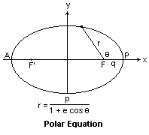
Figure 1-Polar Equation Of Ellipse
Now let c be the distance from the center to either of the foci. Then c = a - p/(1 + e) = ep/(1 - e²) = ea. This is the clearest definition of the eccentricity: e = c/a. We see that e < 1, and that e = 0 gives a circle. These things are illustrated in the diagram at the right. Note especially the right triangle with legs b and c, and hypotenuse a. From this triangle, we can prove that b = a √(1 - e²), which we claimed above. Below the ellipse is shown the canonical equation of an ellipse, which includes the lengths a and b. Two parameters are necessary to specify an ellipse, either a, b or p, e for example
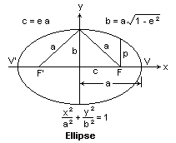
Figure 2-The ellispe description

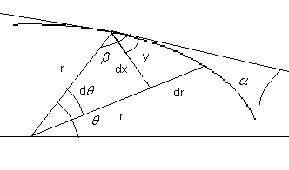
Figure 3-Elements
2-Hope solution:
We can write that:
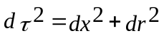
That:
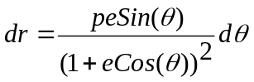 And 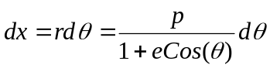
With Replacement:
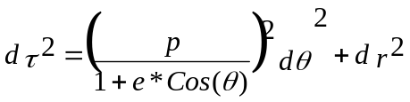
If blow change variable occurred and solved first integral will lead to:

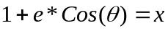
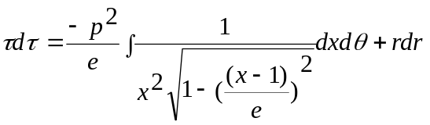
By below variable changing and solving the problem leads to:
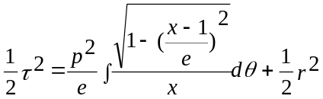
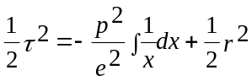

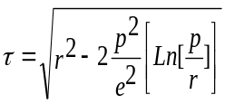

If:
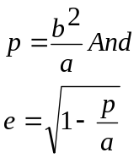

Base on the integral nomination value theorem we have:

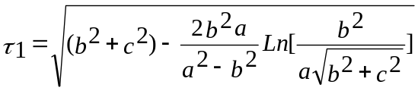
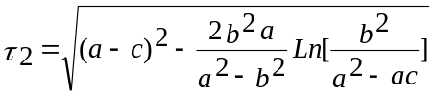
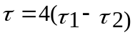
3-Scope Consideration:
The Scope Consideration is derived from symmetry ellipse property. Ellipse is Symmetry of ellipse center and can be divided to four section.

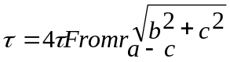
A Problem Occurred when the Ellipse is become a circle.
4.Simulation Consideration:
Simulation Consideration leads to very usefulness result on weak personal computers. It seems to be used of more fast and occurrence computers. All we need is simulation of subsidiary Integral and Formula in a Computer Program.
Reference:
[1]- http://mysite.du.edu/~jcalvert/math/ellipse.htm
[2]-
Calculus and Analytic Geometry–George B.Thomas,Ross- L.Finney Seventh Edition Addision–Wesely,1988

